Iterator pattern is very commonly used design pattern in Java and .Net programming environment. This pattern is used to get a way to access the elements of a collection object in sequential manner without any need to know its underlying representation.

Iterator pattern falls under behavioral pattern category.

## Implementation

We're going to create a *Iterator* interface which narrates navigation method and a *Container* interface which retruns the iterator . Concrete classes implementing the *Container* interface will be responsible to implement *Iterator* interface and use it

*IteratorPatternDemo*, our demo class will use *NamesRepository*, a concrete class implementation to print a *Names* stored as a collection in *NamesRepository*.

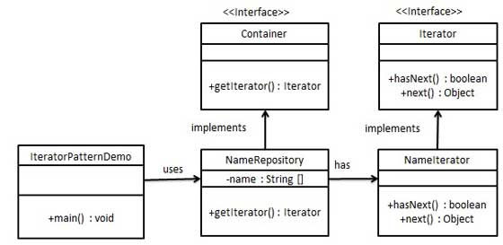

/*******************************************************************************************************/

Example :

/*

* Step 1

* create interface

* Iterator.java

*/

interface Iterator{

public boolean hasNext();

public Object next();

}

/*

* Container.java

*/

interface Container{

public Iterator getIterator();

}

/*

* Step 2

* Create concrete class implementing the Container interface. This class has inner class NameIterator

* ... implementing the iterator interface

* NameRepository.java

*/

class NameRepository implements Container{

public String names[] = {"Robert", "John", "Julie", "Lora"};

@Override

public Iterator getIterator() {

// TODO Auto-generated method stub

return new NameIterator();

}

private class NameIterator implements Iterator{

int index;

@Override

public boolean hasNext() {

if(index < names.length) {

return true;

}

return false;

}

@Override

public Object next() {

if(this.hasNext()) {

return names[index++];

}

return null;

}

}

}

/*

* use the NameRepository to get iterator and print names

*/

public class TestIteratorPattern {

public static void main(String[] args) {

NameRepository nameRepository = new NameRepository();

Iterator iterator = nameRepository.getIterator();

while(iterator.hasNext()) {

String name = iterator.next().toString();

System.out.println("Name : "+name);

}

}

}